**Project Design Phase-II**

**Technology Stack (Architecture & Stack)**

|  |  |
| --- | --- |
| Date | 22 June 2025 |
| Team ID | LTVIP2025TMID31922 |
| Project Name | Edu Tutor AI-Personalized Learning with Generative AI |
| Maximum Marks | 4 Marks |

**Technical Architecture:**

The Deliverable shall include the architectural diagram as below and the information as per the table1 & table 2

**Edu Tutor AI – Personalized Learning Assistant using Hugging Face**

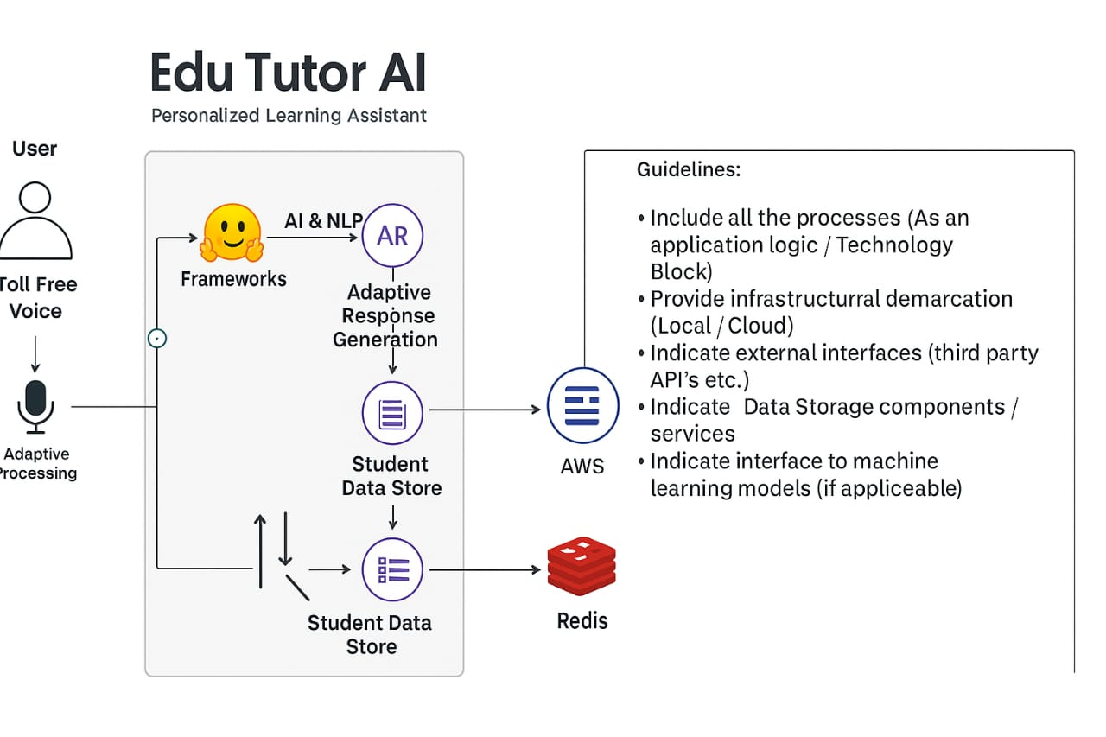

**Reference: https://huggingface.co/models**

|  |  |  |  |
| --- | --- | --- | --- |
| **S.No** | **Component** | **Description** | **Technology** |
|  | User Interface | How user interacts with application | HTML, CSS, JavaScript / Angular Js / React Js etc. |
|  | Application Logic-1 | Handles User registration,login,grade selection | Java / Python |
|  | Application Logic-2 | Query processing and intent detection | Python,FastAPI,Hugging Face Transformers |
|  | Application Logic-3 | Generates personalized learning responses using vector search | Pinecone Vector DB,OpenAI/GPT-4 API |
|  | Database | Stores user data,grade info,session tokens | MySQL, PostgreSQL/Firebase |
|  | Cloud Database | Managed cloud data service | Firebase,MongoDB Atlas,Pinecone(for vectors) |
|  | File Storage | Stores educational files,lessons,user uploads | AWS S3,Firebase Storage,Google Cloud Storage |
|  | External API-1 | Embeds AI language model | Hugging Face Model API/OpenAI API |
|  | External API-2 | Grade-specific curriculum API or Ed-Tech integration | NCERT API,CBSE Content API |
|  | Machine Learning Model | NLP-based model to understand queries and personalize content | Hugging Face Transformers/Custom BERT Model |
|  | Infrastructure (Server / Cloud) | Application Deployment and hosting | Hugging Face Spaces,Heroku |

**Components & Technologies: Table-1**

**Table-2: Application Characteristics:**

| **S.No** | **Characteristics** | **Description** | **Technology** |
| --- | --- | --- | --- |
|  | AI & NLP Frameworks | List of AI/NLP Frameworks used to personalize learning and generate response | Hugging Face Transformers,PyTorch,Tensor Flow |
|  | Data privacy and security | Security controls for protecting student data and ensuring secure access | e.g. SHA-256, HTTPS |
|  | Adaptive Learning Architecture | Architecture to support adaptive content delivery based on learner profiles | Microservices,REST APIs |
|  | Availability | The platform is accessible 24/7 | AWS Load Balancer |
|  | Performance | Fast response to queries,live doubt solving ,and feedback generation | Redis Cache,CDN |

**References:**

**https://huggingface.co/transformers**

**https://tools.ietf.org/html/rfc6749**

**https://owasp.org/www-project-top-ten/**

**https://redis.io/docs/about/**